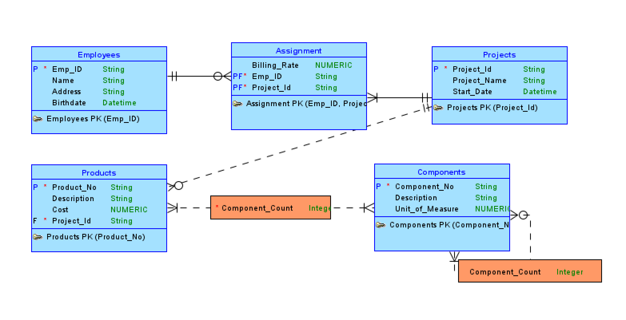

1. No because a project requires at least one employee to be assigned to it.
2. In order to do that, need to add two attributes to the Assignment Entity. We can add Start_Date and End_Date and make the Start_Date a primary key to the entity.

